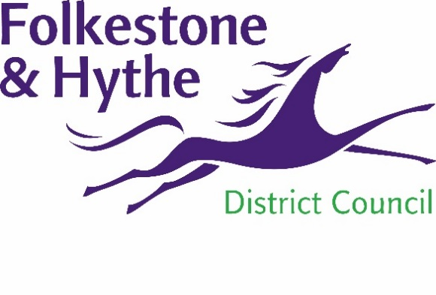
NEWS RELEASE

3 December 2020

COUNCIL PLANNING DECISION ON PRINCES PARADE UPHELD

Permission to appeal the judicial review of the planning permission for the Princes Parade development has been refused today (3 December 2020).
Lord Justice Newey upheld the previous judgement of Mr. Justice Dove – refusing the appeal and upholding the judicial review proceedings in their entirety.
Last November Folkestone & Hythe District Council’s (F&HDC) planning decision was upheld by the High Court with the judge – Mrs. Justice Lieven – rebutting the arguments for judicial review in turn. She awarded up to £5,000 to the council in costs.
Cllr David Monk, Folkestone & Hythe District Council Leader, said: “I am delighted with this outcome. Appropriate due diligence is always applied by the council when considering planning decisions.
“Today’s decision draws a line under a long running saga and provides further vindication that the process the council followed was correct.”
There is no other route of appeal against the decision and the Princes Parade development can now go ahead.

ENDS
Notes to Editors
For more information, please email communications@folkestone-hythe.gov.uk

Follow us on Facebook: @FolkestoneandHytheDC
Follow us on Twitter: @fstonehythedc
Follow us on Instagram: @folkestonehythedc
Follow us on LinkedIn: Folkestone & Hythe District Council

